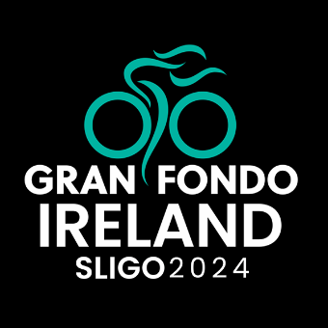
UCI Gran Fondo Ireland – Sunday, 30th June 2024

June 2024

Dear Resident/ Business,

The Gran Fondo World Series is coming to Ireland for the first time ever. This event that will be coming to Sligo on the beautiful west coast of the country will be bringing with it a Global audience to showcase all that Sligo has to offer, a cycling event with a real Irish flare.

The UCI Granfondo World Series is a series of UCI-sanctioned races held all over the world. Gran Fondo Ireland is the first-ever Gran Fondo event in Ireland to be included in the UCI Gran Fondo World Series. The event will begin and culminate in Sligo Town, where all participants will gather and enjoy live entertainment, a finisher’s medal, a Prize Presentation show, food, drink and much more.

In the spirit of the World Gran Fondo Series, the Gran Fondo Ireland is a highly energetic public cycling event attended by pros, recreational cyclists, and weekend warriors. Gran Fondo Ireland incorporates timed overall routes, fantastic rest stops, route support mechanics to make sure all cyclists keep rolling along.

Gran Fondo Ireland has teamed up with Sligo County Council & Fáilte Ireland for this great event. This event will take place around Sligo and its environs on the 30th June 2024.

We are contacting you in advance to share important information about the event with particular emphasis on the event’s effect in your area.

There will be one route catering to 2,000 cyclists. The event will start at 07:30hrs from Wine Street and will finish along Cleaveragh Park, at approximately 16:30hrs. The event is being assisted by An Garda Síochána, who, where possible, will guide participants travelling through junctions.

Expect delays along the route at approximate times and areas as follows:

Area | Fastest Cyclist | Slowest Cyclist
Wine Street, Sligo | 07:30am | 08:12am
Strandhill | 07:41am | 08:45am
Ballysadare | 08:00am | 09:29am
Coolaney | 08:17am | 10:08am
Ballymote | 08:41am | 11:26am
Riverstown | 08:54am | 11:58am
Ballygawley | 09:20am | 13:01pm
Ballysadare (2nd lap) | 09:26am | 12:46pm
Coolaney (2nd lap) | 09:42am | 13:25pm
Ballymote (2nd lap) | 10:07am | 14:23pm
Riverstown (2nd lap) | 10:20am | 14:55pm
Ballygawley (2nd lap) | 10:48am | 16:08pm
Doorly Park, Sligo | 11:00am | 16:29pm

An overview map of the route can be found at www.granfondoireland.ie/#routes

The event organisers are working in partnership with An Garda Síochána to ensure safe travelling of residents and cyclists along the route for the duration of the event. We will also have a team of experienced and trained marshals around the course.

A complete and comprehensive traffic management plan will also be implemented around the event, including diversionary routes for motorists, pre-event route notifications and route signage.

We appreciate that this will impact travel significantly and we really appreciate your cooperation, and we apologise for any inconvenience that may be caused.

If you want to contact us about this notice, please email hello@granfondoireland.ie. Alternatively, you can call 01 429 0004.

If you would like to speak to us about the event or the road closures please visit us in the foyer of Sligo City Hall on Tuesday, 25th June from 16:00-18:30.

Event entries are available at www.granfondoireland.ie

Yours Sincerely,

Gran Fondo Ireland Team.

