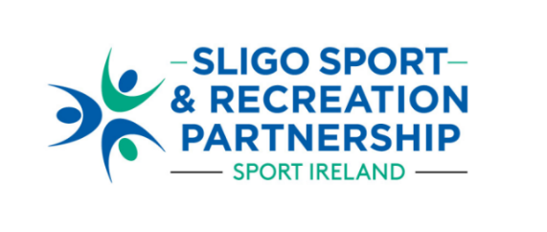

**Call for Nominations to join the**

**Board of Directors of Sligo Sport and Recreation Partnership 2024**

**NOMINATION FORM**

**Option 1: Self Nomination**

|  |  |
| --- | --- |
| **NOMINATION DETAILS** | |
| **Name** |  |
| **Address** |  |
| **Gender** |  |
| **Involvement in group/organisation (if relevant)** |  |
| **Membership of other Boards/Directorships** |  |
| **Contact No.** |  |
| **Email** |  |
| **Available to attend meetings at 4.30pm (weekdays)** | **Yes No** |

|  |
| --- |
| **Outline current/ past level of involvement within the sport and physical activity sector.** (150-200 words) |
|  |

|  |
| --- |
| **Please provide details of relevant knowledge and skills the nominee can bring to the SSRP Board**: *e.g.**sports development, community development, HR, finance, legal, company law, risk management, digital skills, communications.* (150-200 words**)** |
|  |

|  |
| --- |
| **Outline specific areas of interest where the nominee can contribute to the SSRP Board.** (150-200 words) |
|  |

|  |
| --- |
| **SIGNATURE:** |
| **SIGNED: ________________________________________**  **DATE: ___________________________________________** |

|  |
| --- |
| **RETURN DETAILS** |
| Please return completed Nomination Form to:  [**info@sligosportandrecreation.ie**](mailto:info@sligoportandrecreation.ie) by the return date of:  **5pm on Monday 21st October 2024.**  A sub-committee of the Board will assess nominations after which applicants will be notified of the outcome.  For any queries, please contact 07191 61511 or email [info@sligosportandrecreation.ie](mailto:info@sligosportandrecreation.ie) |