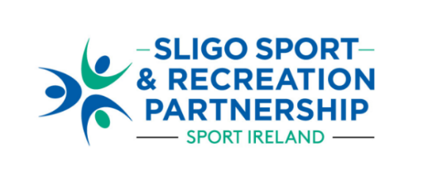

**Call for Nominations to join the**

**Board of Directors of Sligo Sport and Recreation Partnership 2024**

**NOMINATION FORM**

**Option 2: Nomination of Individual by Club/Group**

Please get consent from the proposed nominee to ensure GDPR compliance and to confirm that they will be able to fulfil the required commitments of the role before making the nomination.

|  |  |
| --- | --- |
| **NOMINATING CLUB/GROUP DETAILS** | |
| **Name of Club/Group making nomination** |  |
| **Name of person completing nomination form** |  |
| **Address of person making nomination** |  |
| **Email** |  |
| **Contact No** |  |
| **Role in the Club/Organisation** | **Chair _______**  **Secretary __________**  **Other (Please specify) __________________** |

|  |  |
| --- | --- |
| **NOMINATION DETAILS** | |
| **Name** |  |
| **Address** |  |
| **Gender** |  |
| **Involvement in group/organisation (if relevant)** |  |
| **Membership of other Boards/Directorships** |  |
| **Contact No.** |  |
| **Email** |  |
| **Available to attend meetings at 4.30pm (weekdays)** | **Yes No** |
| **Outline current/ past level of involvement within the sport and physical activity sector.** (150-200 words) | |
|  | |

|  |
| --- |
| **Please provide details of relevant knowledge and skills the nominee can bring to the SSRP Board**: *e.g.* *sports development, community development, HR, finance, legal, company law, risk management, digital skills, communications.*(150-200 words) |
|  |

|  |
| --- |
| **Outline specific areas of interest where the nominee can contribute to the SSRP Board.** (150-200 words) |
|  |

|  |
| --- |
| **SIGNATURE:** |
| **SIGNED: ________________________________________**  **DATE: ___________________________________________** |

|  |
| --- |
| **RETURN DETAILS** |
| Please return completed Nomination Form to:  [**info@sligosportandrecreation.ie**](mailto:info@sligosportandrecreation.ie) by the return date of:  **5pm on Monday 21st October 2024**.  A sub-committee of the Board will assess nominations after which applicants will be notified of the outcome.  For any queries, please contact 07191 61511 or email [info@sligosportandrecreation.ie](mailto:info@sligosportandrecreation.ie) |